PIZZA SALES SQL QUERIES

Problem statement

Q1 Find Total Revenue.

SELECT (ROUND(SUM(total_price)),2) AS Total_revenue

FROM pizza_sales;

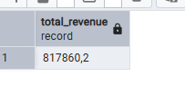

Q2 Find the average order value

SELECT (ROUND(AVG(unit_price)),2)

FROM pizza_sales

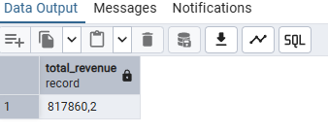

Q3 Total Pizza sold

SELECT SUM(quantity) AS Total_pizza_sales

FROM pizza_sales

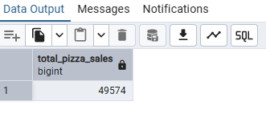

Q4 Total No. of orders

SELECT COUNT(DISTINCT Order_id) AS Total_Order

FROM Pizza_sales

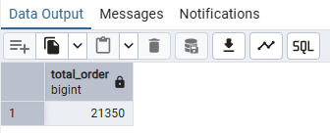

Q5 Average Pizzas per Order

SELECT (SUM(quantity) / COUNT(DISTINCT order_id)) AS Avg_sale

FROM pizza_sales

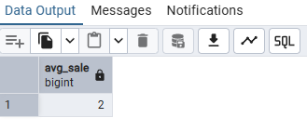

Q6 Daily Trends for Total Orders

SELECT

TO_CHAR(order_date, 'Day') AS order_day,

COUNT(DISTINCT order_id) AS total_order

FROM

pizza_sales

GROUP BY

TO_CHAR(order_date, 'Day')

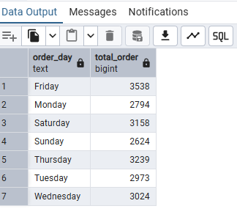

Q7 Hourly Trend for total orders

SELECT

TO_CHAR(order_time, 'HH24:MI') AS order_time,

COUNT(DISTINCT order_id) AS total_order

FROM

pizza_sales

GROUP BY

TO_CHAR(order_time, 'HH24:MI')

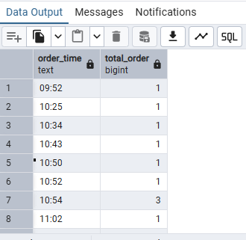

Q8 Sales By Pizza category

SELECT

pizza_category,

ROUND(SUM(total_price)::NUMERIC, 2) AS total_sales

FROM

pizza_sales

GROUP BY

pizza_category;

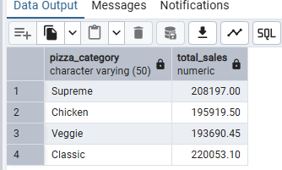

Q9 Sales By Pizza Size

SELECT Pizza_size, ROUND(SUM(total_price):: NUMERIC,2) AS total_sale

FROM pizza_sales

GROUP BY pizza_size

ORDER BY total_sales

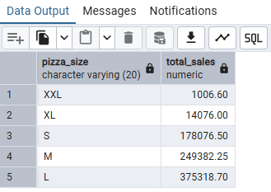

Q10 Total PIzza Sold By Pizza Category

SELECT

SUM(quantity) AS total_sold, Pizza_category

FROM

pizza_sales

GROUP BY

Pizza_category

ORDER BY

total_sold DESC

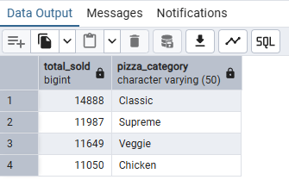

Q11 Top 6 Best sellers By Total Pizza Sold

SELECT * FROM pizza_sales

SELECT

pizza_name_id,

SUM(quantity) AS total_Sold

FROM

pizza_sales

GROUP BY

pizza_name_id

ORDER BY total_sold DESC

LIMIT 6

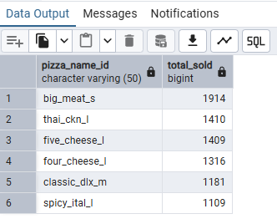

Q12 Bottom 5 Worst Sellers By Total Pizza Sold

SELECT

pizza_name_id,

SUM(quantity) AS total_Sold

FROM

pizza_sales

GROUP BY

pizza_name_id

ORDER BY

total_sold ASC

LIMIT 6

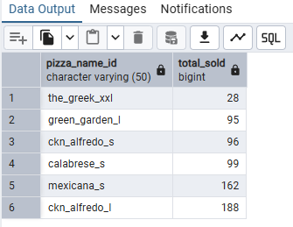

Pizza Craft Dashboard

